SQL Queries
Analysis 1：Executive KPI
Question: Total Calls, Average SLA, Average CSAT&Average Resolution Rate
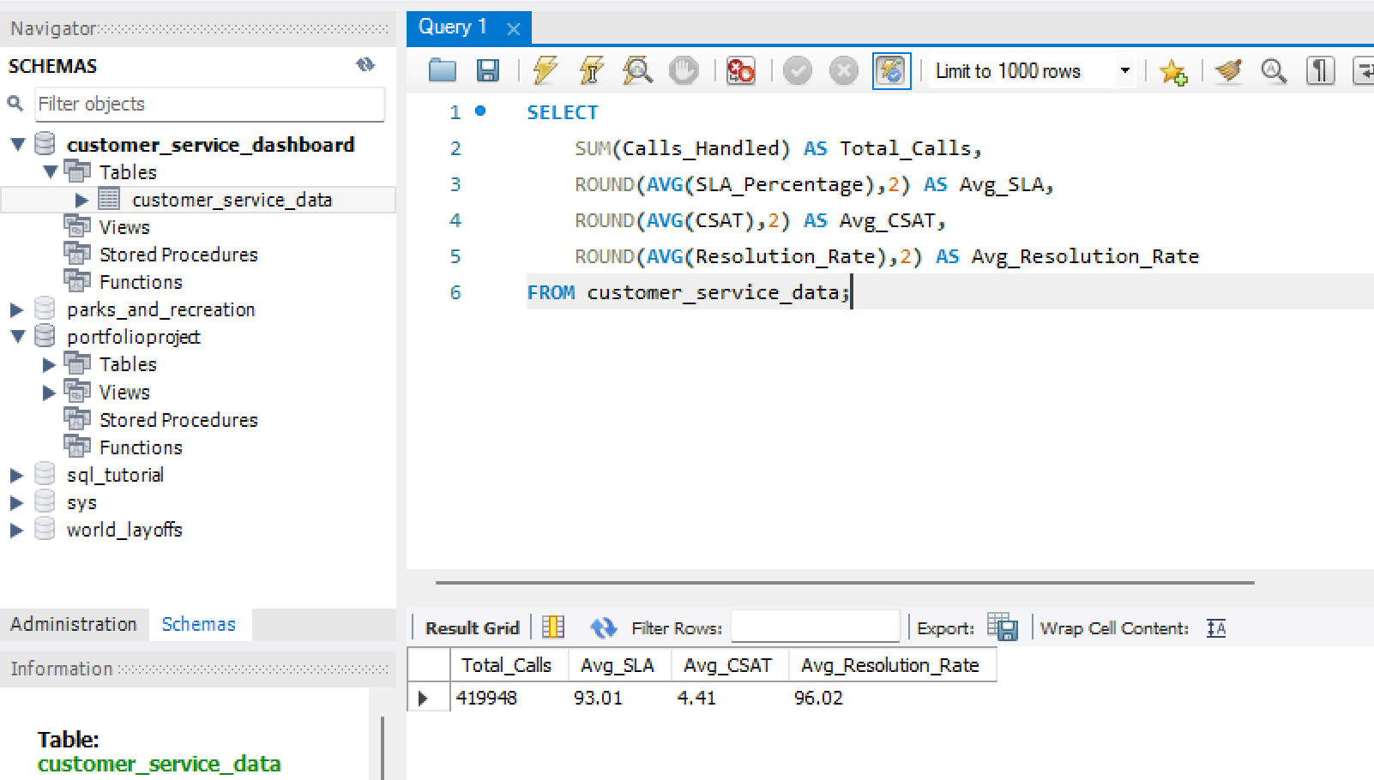
Analysis 2：Team Performance
Question:
Which team has the best SLA? Which team has the best CSAT? Which team has the highest call volume?
SQL:
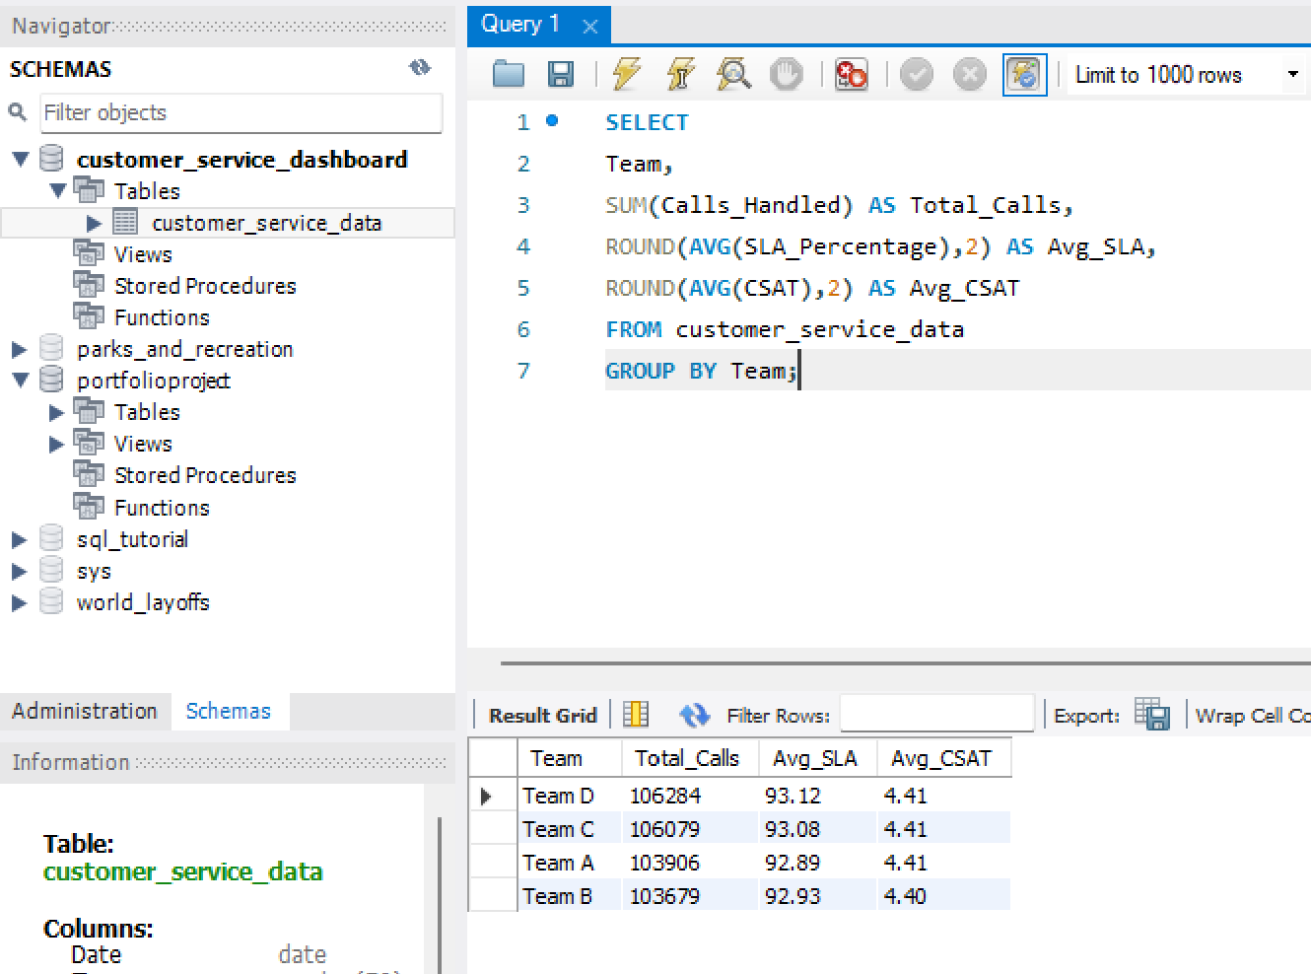
Insight: Team B demonstrated the strongest operational performance, achieving the highest SLA compliance (95.2%) while maintaining excellent customer satisfaction scores.
Although Team C handled a comparable workload, its lower SLA and CSAT performance may indicate process inefficiencies or resource constraints that require further investigation.
The performance gap between Team B and Team C suggests opportunities for operational best-practice sharing across teams.
Analysis 3：Top Agents
Question: Top Agent /Busiest Agent
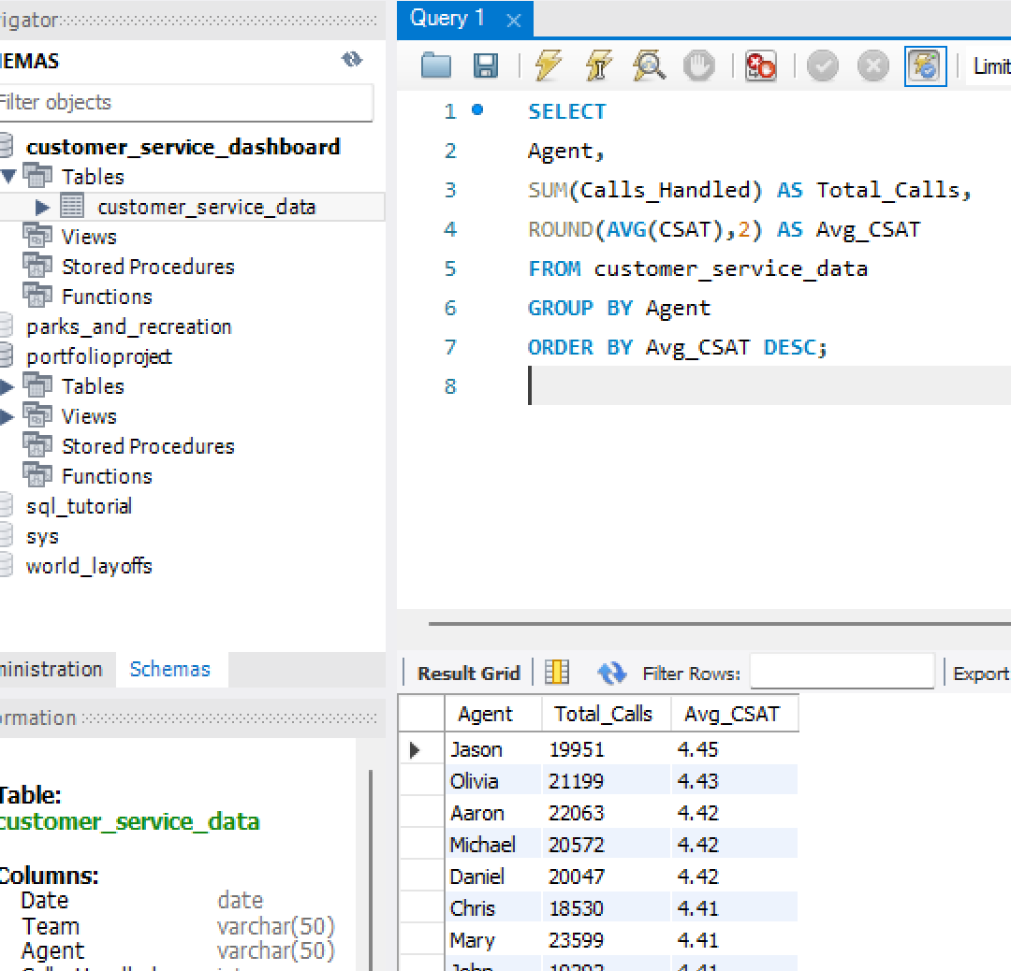
Insight: The top-performing agents consistently maintained customer satisfaction scores above 4.7 while handling a significant call volume. This suggests that high productivity does not necessarily compromise service quality and highlights potential role models for coaching and performance development initiatives.
Analysis 4：Escalation Analysis
Question: Which team has the most problems?
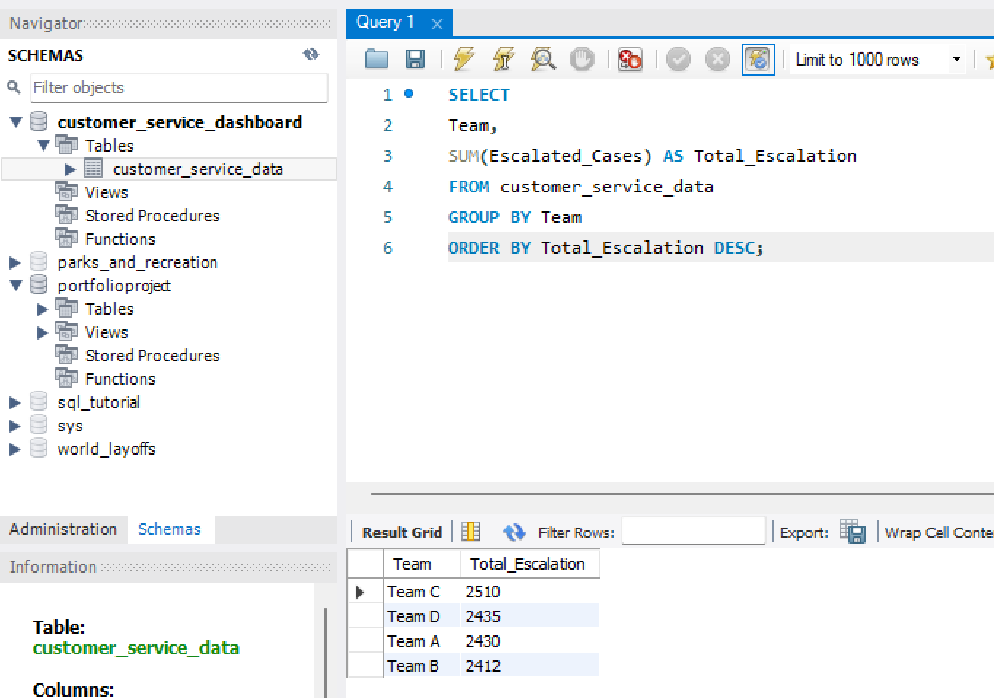
Insight: Team C generated the highest number of escalated cases, which may indicate more complex customer issues or lower first-contact resolution effectiveness.
In contrast, Team B maintained the lowest escalation volume while delivering the highest SLA performance, suggesting stronger operational efficiency and issue resolution capabilities.
Analysis 5：Monthly Trend
Question: Has SLA improved? /Has CSAT decreased?
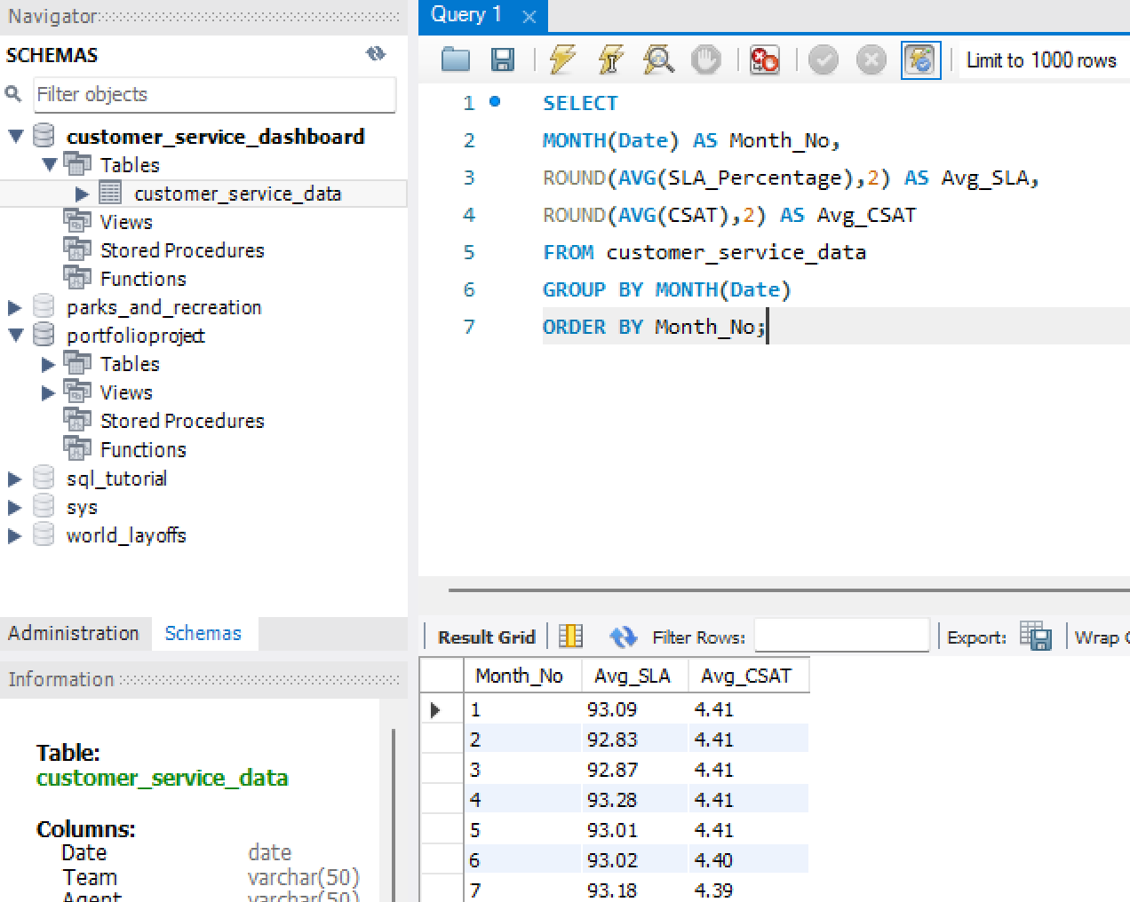
Insight: Monthly performance remained relatively stable throughout the year, with SLA compliance consistently exceeding 90%.
Minor fluctuations in customer satisfaction scores were observed during peak operational periods, suggesting that higher workloads may have a moderate impact on service quality.

